Newsletter

November 2016

2016 Directors

President: Ron Howard

Vice-President: Tony Herrera

Secretary: David Allen
Treasurer: Juanita Gillaspey

Sergeant-at-Arms: Patrick Smith

Past President (2015): Sandee Anderson

Appointed Positions

Historian: Group Effort
Photographer: Group Effort
Sunshine: Sandee Anderson
Activities: Group Effort

Event Reminder: Sheron Leigh

Membership: Robert Thiel
Webmaster: Cathy York

Parade Coordinator: Nena Herrera

NCM Ambassador: Len Atlas

CORVETTE Weekend: Ron Howard

(Refer to Membership Roster for contact information)

Membership

November Birthdays
Milton Reasor 11/4 Bill Whitlock 11/17
Jim Roarty 11/7 Gary Masters 11/23
Luis Brito 11/9 Pat Dobson 11/29
Kathy Dennis 11/9

November Anniversaries
Ken & Judy Axling Bill & Georgia Whitlock
Luis & Heidi Brito Don & Chris Wilson
Bruce & Linda Cochran

SOCA Logo Apparel
Contact Tony Herrera

Next Club Social

October 22-SOCA Monthly Social, Poker Run in Grants Pass. Dinner at Elmer’s Grants Pass and prizes for the best poker hands.

Please RSVP to Sheron Leigh, 541-955-9224,
1gypsyleigh@gmail.com if you would like to
attend.

Why Join SOCA?
- Promote esprit-de-corps among Corvette enthusiasts.
- Create interest in the Corvette as a true dual-purpose sports car.
- Provide a means of technical information and service to members.
- Encourage dealer and manufacturer cooperation.
- Organize and promote events of a social nature and provide social gatherings for enthusiasts with common interest.
- Sponsor or participate in activities to benefit the community through recognized charities as selected by the members of the Association.
- SOCA Constitution -

Upcoming Meetings
General Membership: Wednesday, Nov. 2,
7:00 PM, Rogue River Community Center.
Visitors are always welcome!

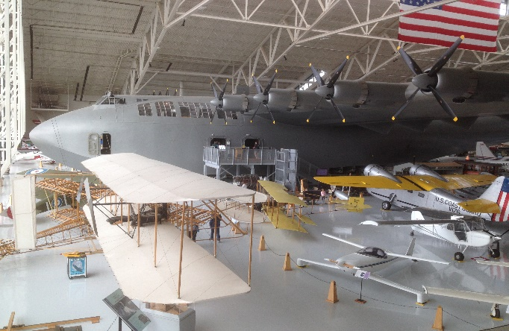

The Spruce Goose at the Evergreen Aviation Museum
in McMinnville, Oregon. 21 cars made the trip.

Events & Activities

October 22-SOCA Monthly Social, Poker Run in Grants Pass. Dinner and prizes for the best poker hands at Elmer’s Diner in Grants Pass just off I-5 exit #55. Gathering time will be at 4:30 pm to get your first cards. Details to follow.

November- Due to the Thanksgiving holiday the social event will be discussed and scheduled later.

December 10-Annual Christmas Party at Mac’s Diner TBA
Christmas Tree Auction at Providence TBA

For additional events, information and links, go to the S.O.C.A. website Events Page
http://www.sovette.com/default.asp?pg=activities

Techin & Toolin

Driving Through Tire Blowouts – The Tire Rack
The term "blowout" is generally used by drivers to describe a bursting tire accompanied by a rapid loss of air pressure. While one might assume that all blowouts are caused by too much internal pressure bursting a weak spot in the tire, the main reason for them is just the opposite. Most blowouts are caused by too little air pressure allowing the tire to flex beyond its elastic limits until it overheats to the point where the rubber loses its bond to the internal fabric and steel cord reinforcement.
Tire blowouts are usually the result of overloading the vehicle, impact damage (either immediate or delayed depending on severity of the impact), a massive cut that causes rapid air loss, or an unnoticed small puncture that allows the tire to slowly lose air over time until it fails. Blowouts are typically caused by anything that allows air to escape and prevents the tire from supporting the weight of the vehicle.
While tires have become so reliable that "blowouts" are an uncommon occurrence today, their lack of frequency only makes them more surprising and potentially more dangerous when they do occur. Regardless of the cause, what a driver does following a blowout can be the difference between a simple inconvenience or ending up in-the-ditch.
BANG...whoosh...flap...flap...flap...flap! In less than a quarter of a second your drive has gone from cruising to cursing.
Reacting to the surprise of the loud noise and a jerk of the steering wheel, many drivers' first reactions are to lift off of the accelerator, hit the brakes and quickly steer the vehicle to the side of the road. Unfortunately, these typical reactions have been shown to be dangerous, and may make it more difficult for the driver to maintain control.
However, preparation begins before the blowout occurs. You will not be ready to respond if you drive with one hand holding a cup of coffee and the other arm resting on the top of the steering wheel. Proper seat and hand position will give you better odds of dealing with any driving situation.
If you experience a blowout, it doesn't make any difference if you are driving a sports car, sporty coupe or sport utility vehicle; the same procedures are appropriate. The driver should step on the accelerator for an instant to preserve vehicle momentum (or at least maintain constant accelerator pedal pressure), and offset the pulling caused by the blown tire by gently counter steering to keep the vehicle in its lane. Once the vehicle has stabilized, the driver can gently slow down and begin to carefully pull over to the side of the road.
Members of the Tire Rack team had the chance to experience tire blowouts at highway speeds at Michelin's Laurens Proving Grounds. Tire after tire was sacrificed as participants were allowed to drive vehicles fitted with tires rigged with explosives attached to their sidewalls (a rear tire on a full-size SUV and a front tire on a full-size sedan). These tires were literally "blown out" with all of the accompanying noises.
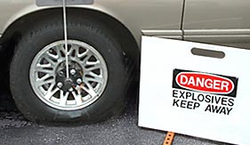  Before |  | 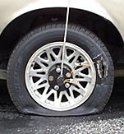  After
While our drivers faced the initial intimidation of knowing they might be challenged to maintain vehicle control, we found that following the recommended procedures allowed us to easily continue in our original lane and gently slow down. Essentially our drivers learned you should continue to drive "through" tire blowouts to maintain vehicle control and worry about determining the cause of the problem later.
Remember: These are techniques, not guarantees. Please drive safely.

Alternating Winter and Summertime Tires – The Tire Rack
Wintertime travel often increases behind-the-wheel apprehension for drivers living in America's snowbelt. Shorter days and colder temperatures, as well as slush-, snow- and ice-covered roads all conspire to challenge a driver's patience, skills and their tires' traction, adding tension to daily commutes and holiday trips.

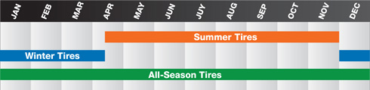
Seasonal Application of Major Tire Types
Rubber compounds are tuned for the ambient temperatures the tires are designed to encounter. Summer tires are best for warm conditions and winter/snow tires are best for cold. And while an all-season tire's name suggests year-round capabilities, they often prove to be a Jack-of-all-trades, master of none.
During a typical vehicle's ownership cycle or lease period, drivers will purchase at least one set of replacement tires. Since the cost of winter tires is generally equivalent, if not less than replacement tires for the vehicle, this means that equipping the vehicle with winter tires will enhance tire traction when driving conditions are at their worst without increasing the driver's overall operating costs.

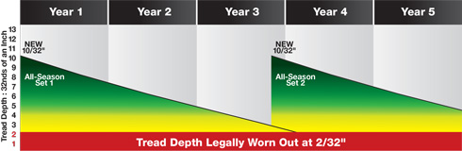
Service Life of All-Season Tires Used Year Round
Running typical all-season tires continuously means they will wear out in about three years of use and may need to be replaced before starting the third winter.
While dedicated winter tires are tuned to provide the best possible traction when road conditions are at their slipperiest, some drivers believe using them means having to buy an extra set of tires. However the point they often overlook is that the tires they use during spring, summer and fall don't experience any wear when they are stored during winter, which means those tires will be able to deliver more summers of service.

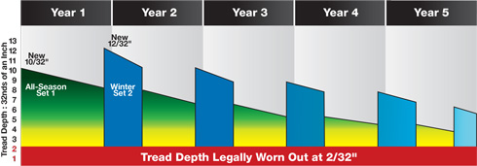
Service Life of All-Season Tires Combined Seasonally with Winter Tires
Alternating winter/snow tires seasonally extends the years of service received from both sets of tires.
Our experience has taught us that alternating between two sets of tires that have been designed for the driving conditions (summer's hot, dry and wet roads vs. winter's cold, slush, snow and ice) means having the best tires to overcome driving challenges all year round, and helps extend the combined years of service drivers get from both sets. Start your winter on the right tires.

Disclaimer - Discretion is advised. The preceding information may not apply to specific vehicles or all circumstances. Always refer to the manufacturer’s specifications, service manuals, technical data and product information.

